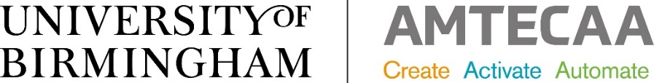

www.birmingham.ac.uk/amtecaa

Which Advanced Manufacturing Technologies Could Help
Your Business?
Workshops Selection:
Please indicate which sessions you would like to attend, complete your company details on the final page and return the form to amtecaa@contacts.bham.ac.uk
Numbers are limited to 10 companies per workshop and each technology is repeated twice per month. Companies are welcome to attend more than one workshop.

DATE | TIME START | TECHNOLOGY  TOPIC | Attendee Name
4 FEBRUARY | 9.30am | METAL ADDITIVE LAYER MANUFACTURING (ALM)
4 FEBRUARY | 2.00pm | SUBTRACTIVE MANUFACTURING
9 FEBRUARY | 9.30am | PLASMA MANUFACTURING
9 FEBRUARY | 2.00pm | LASER MANUFACTURING
11 FEBRUARY | 9.30am | SUBTRACTIVE MANUFACTURING
11 FEBRUARY | 2.00pm | HYBRID MANUFACTURING
16 FEBRUARY | 9.30am | ROBOTICS & AUTOMATION
16 FEBRUARY | 2.00pm | MEDICAL DEVICES  DESIGN & MANUFACTURE
18 FEBRUARY | 9.30am | HYBRID MANUFACTURING
18 FEBRUARY | 2.00pm | PLASMA MANUAFCTURING
23 FEBRUARY | 9.30am | LASER MANUFACTURING
23 FEBRUARY | 2.00pm | ROBOTICS & AUTOMATION
25 FEBRUARY | 9.30am | MEDICAL DEVICES DESIGN & MANUFACTURE
25 FEBRUARY | 2.00pm | METAL ADDITIVE LAYER  MANUFACTURING (ALM)
2 MARCH | 9.30am | METAL ADDITIVE LAYER MANUFACTURING (ALM)
2 MARCH | 2.00pm | MEDICAL DEVICES  DESIGN AND MANUFACTURE
4 MARCH | 9.30am | PLASMA MANUFACTURING
4 MARCH | 2.00pm | LASER MANUFACTURING
9 MARCH | 9.30am | SUBTRACTIVE MANUFACTURING
9 MARCH | 2.00pm | HYBRID MANUFACTURING
11 MARCH | 9.30am | ROBOTICS & AUTOMATION
11 MARCH | 2.00pm | SUBTRACTIVE MANUFACTURING
16 MARCH | 9.30am | HYBRID MANUFACTURING
16 MARCH | 2.00pm | PLASMA MANUFACTURING
18 MARCH | 9.30am | LASER MANUFACTURING
18 MARCH | 2.00pm | METAL ADDITIVE LAYER MANUFACTURING
23 MARCH | 9.30am | MEDICAL DEVICES  DESIGN AND MANUFACTURE
23 MARCH | 2.00pm | ROBOTICS & AUTOMATION

WORKSHOP REGISTRATION FORM:
COMPANY NAME:
ADDRESS:
WEBSITE:
Your Name and email:
Company products/Sector:
No. employees:
Technology Assistance required:

A ZOOM MEETING LINK WILL BE EMAILED TO YOU NEARER THE DATE OF THE WORKSHOP
If we are unable to accommodate you in your first choice workshop we will contact you to confirm another suitable date.
Any questions please email: j.bahra@bham.ac.uk Telephone: 07454 521 030

